

**CS542-Project**

User Guide

**Contents**

1. Project at a glance

Overview

Buttons

1. Get Started

Setup Environment

Topology File Selection

1. Use Application

Add a Node

Delete a Node

Edit Edge

View Adjacency Matrix and Connection Table

View Shortest Path

View Graph

7

5

3

2

1

**Project at a glance** 1

Overview

1 2

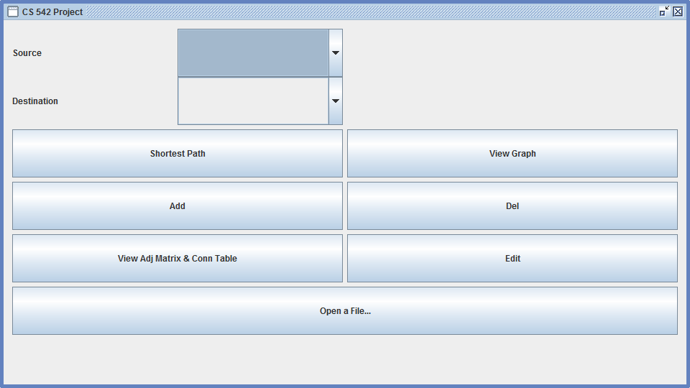

3 4

5 6

7 8

9

Buttons

1. Dropdown to select Source Node
2. Dropdown to select Destination Node
3. Shortest Path – Display the shortest path between source and destination
4. View Graph – Topology Table with path from Source to Destination
5. Add – To add a Node
6. Del – To delete a Node
7. View Adj Matrix & Conn Table – Display Adjacency matrix and Connection Table
8. Edit – To edit edge in Matrix Table
9. Open a File – To browse for location of a topology.txt file

**Get Started** 2

Setup Environment

1. Set path for java executable
2. Download jar file in a directory
3. Run jar file using following command

🡪 java –jar filename.jar

Following Menu will be displayed –



Topology File Selection

Click Button 9 - Open a File…

Select topology.txt file

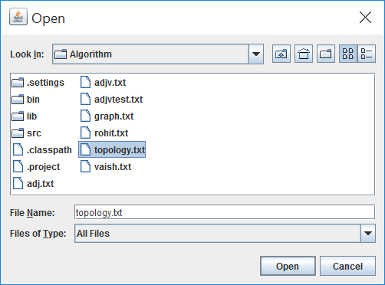

**Note:** You cannot use application features unless you upload a matrix/topology file as per Appendix A

**Use Application** 3

Add a Node

Click Button 5 - Add

Following popup window will be displayed

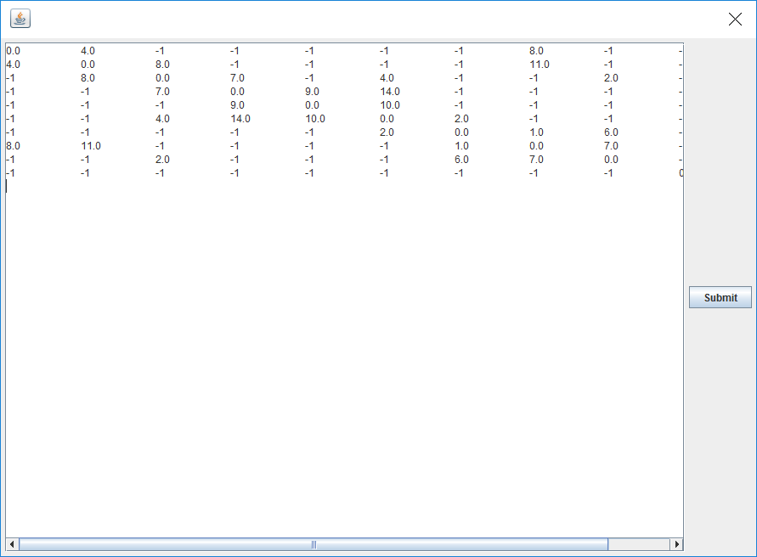

A Disconnected Node will be added to the Matrix by default (Additional row and column with infinite weights will be added)

You can edit the weights of the edges of the new Node and then press “Submit”.

**Note:** If file does not meet the assumptions as stated in Appendix A then Node will not be added and Error will be displayed.

Delete a Node

Click Button 6 - Del

Following popup window will be displayed

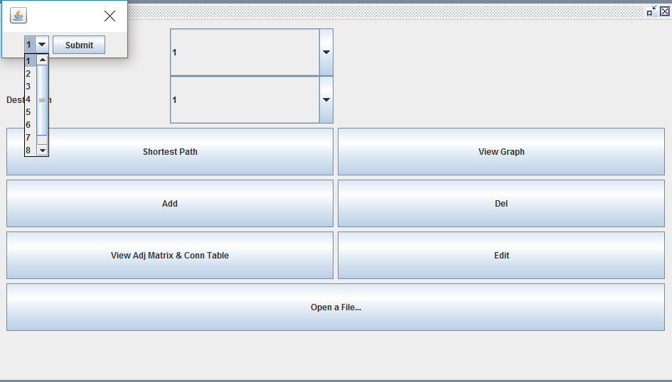

From Drop down window select Node to delete and click “Submit”.

**Note:** If Node is deleted then Node sequence numbers will be changed. Let say i.e. if Node 1 is deleted then Node 2 will become Node 1, if Node 2 is deleted then Node 3 will become Node 2 and so on.

**If all nodes are deleted you have to select topology Matrix file and start over again**.

Edit Edge

Click Button 8 - Edit

Following popup window will be displayed

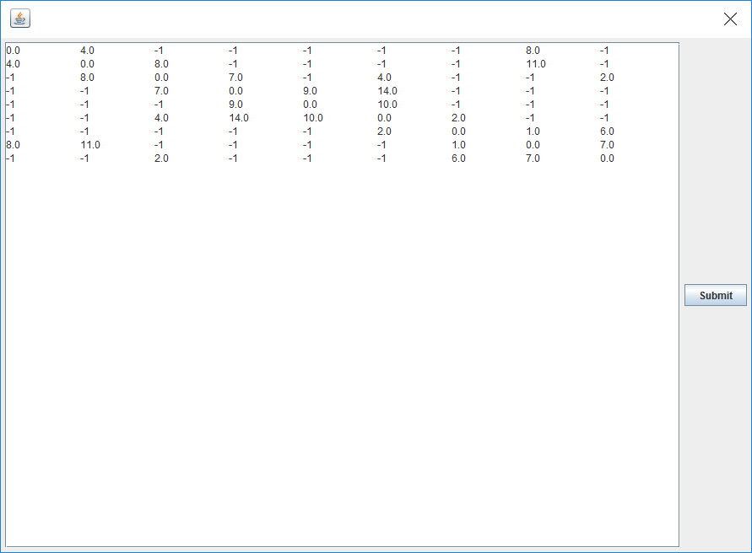

You can edit the weights of the edges of the existing Nodes. Edit the weight and then press “Submit”.

**Note:** If file does not meet the assumptions as stated in Appendix A, then after edge edit operation Error will be displayed.

View Adjacency Matrix and Connection Table

Click Button 7 - View Adj Matrix & Conn Table

Following popup window will be displayed

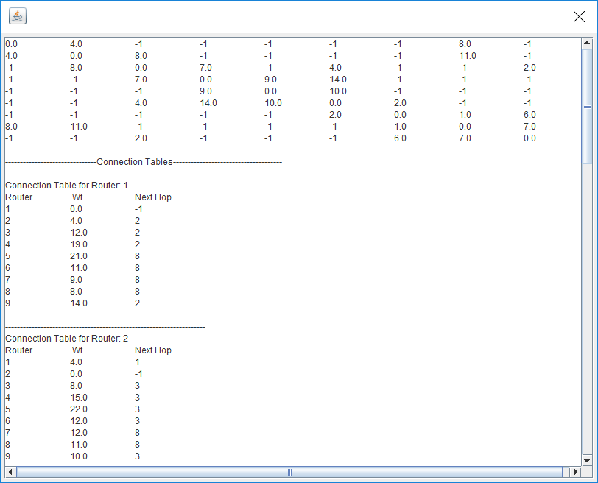

You can view Adjacency Matrix and Connection Tables of All Nodes.

View Shortest Path

Select Source and Destination Nodes.

Then Click Button 3 - Shortest Path

Following popup window will be displayed

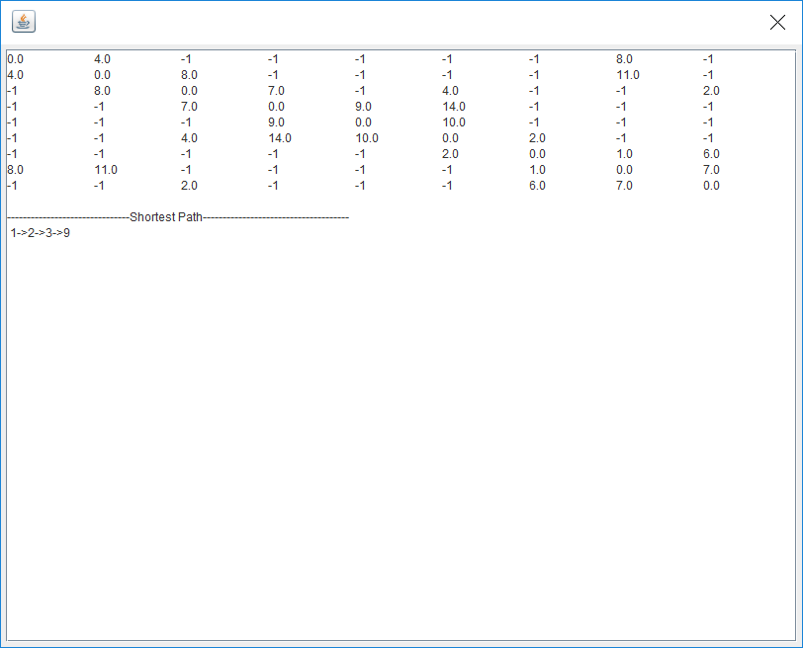

**Note:** If you select Source and Destination as Same Node then it will show an Error as “Source and Destination are Same”

View Graph

Click Button 4 - View Graph

Following popup window will be displayed once you have uploaded the file. Nodes are in Red color.

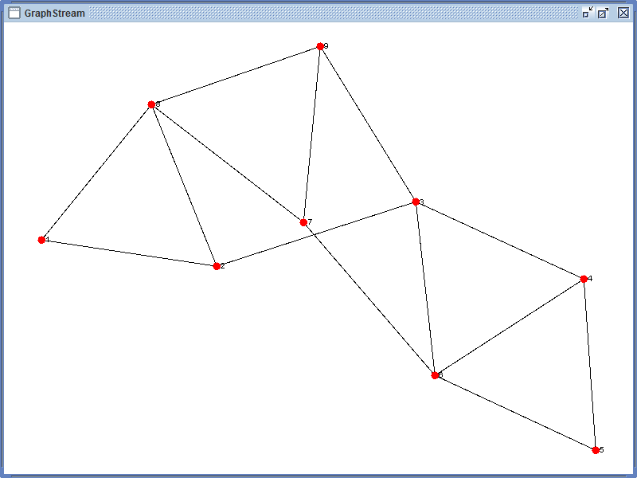

Once you find the shortest path between Source and Destination (Source 1-Destination9) following popup will be displayed with Nodes in the path marked as Green.

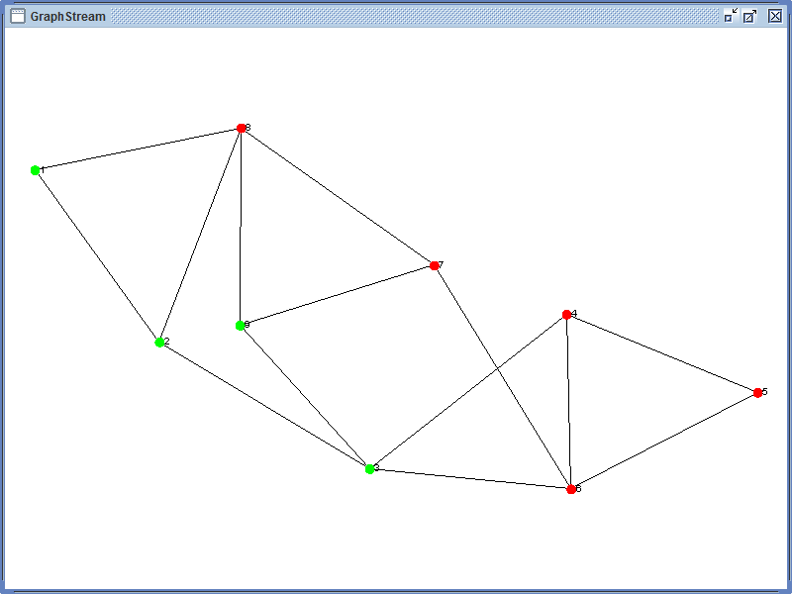

**Note:** Multipath will not be shown in the graph. Every time if you update Source and Destination nodes, you need to click on “Shortest Path” Button and then generate the graph.

**Appendix A**

For the Application to run properly the following criterion should be met:

1. Weight of a Node to itself will be “0” i.e., the diagonal of a Matrix should be zero.
2. A Node may not be directly connected to another Node for which weight will be Positive Infinity and represented by “-1” in Matrix.
3. An Edge of a Node other than as mentioned in Point a & b cannot have a zero or a negative weight.
4. Matrix must be a Square Matrix i.e., number of columns equal to the number of rows
5. Only single space separated file.
6. File cannot have any characters other than numbers.